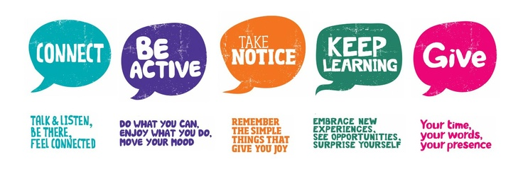
Wellbeing Week

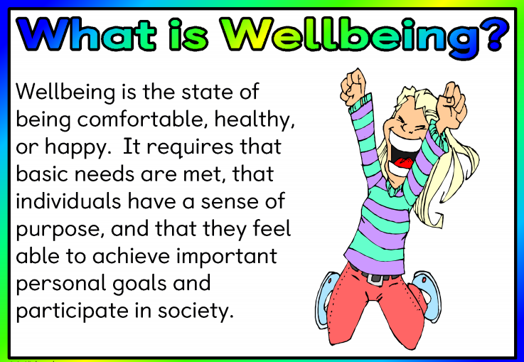
Hi Class,
This week we are focussing on our wellbeing. In the timetable for the week, each day has activities for you to choose from but if you want to mix and match you can, of course. do that too. Every day you can check in with your feelings, using the feelings scale. You can do this with a parent or by yourself.

5th Class Wellbeing Week 15th-19th June 2020
Below you will find a timetable with a menu of different activities for each day. You get to choose what you want to do on each day. Click the links to take you to the activity.
Mindful Monday | 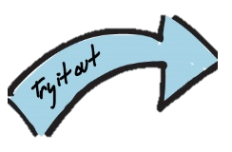  Try it Tuesday | 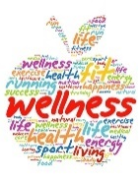  Wellness Wednesday | 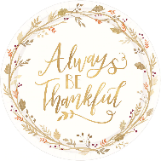  Thankful Thursday | Fitness Friday
Mindfulness Colouring option 1  Option 2 | Finger Knitting  Read the description box for individual videos. | Read your favourite book | Daily Gratitude journal | Pe with Joe wicks
Mindful activities cards  Mindful Activities cards Set 2 | Paper bookmark  Read the description box for individual videos. | Write a letter to your friend. | Self-appreciation | Move Well Move Often- Skills development
 | Plant an apple tree  (You’ll need grown up help) | Fill in a wellness journal page.
Step by step drawing.  1. Draw with Rob  2. Hooplakids Doodle  3. Cartooning Club  4. Draw so Cute  5. Draw with Don Conroy | A different way to lace your shoes | Have a chat with someone in your family | Gratitude scavenger hunt | Yoga
Mindfulness podcast moments.  1. Mindfulness of the brain.  2. Body Scan  3. Leaves on a stream  4. Dropping the Anchor  5. Notice five things  6. Being mindful | Paper toys-  Origami | Start a wellness calendar. | Compliment cards | Get Ireland Active  (Tons of games in here to try)
Tense and relax activity | Photo scavenger hunt | Spread some positivity | Gratitude Bingo | Ten @ 10

