4th Class- Ms. Kinsella’s Activities 15/06/20-19/06/20
Dear parents, guardians and students,
I hope that everyone is keeping safe and well during this difficult time. As we come towards the end of the school year, I have put together this list of activities to keep you entertained over the summer holidays. Thank you for being such a fantastic class and I wish you all every success in 5th class!
Just a reminder my email is mskinsellamell@gmail.com
Many thanks for your support this year,
Ms. Kinsella.

Maths:
- We have now completed every chapter in our maths books but we still have the Look backs to do. There’s 22 revision pages in total between the big book and Shadow book (they’re in grey print in the contents section) so I would recommend working on those.
Fourth Class Revision
1,000mls = 1 litre 1,000g=1kg
500mls = 1/2 a litre 500g=1/2 a kg
250mls = 1/4 of a litre 250g=1/4 of a litre
750mls=3/4 of a litre 750g=3/4 of a litre

100cms=1 metre 10 millimetres in a centimetre
50cms=1/2 a metre 20 millimetres in two centimetres
25cms=1/4 of a metre 30 millimetres in three centimetres

3640.06
The first number to the left of the decimal point stands for units.
The second number to the left of the decimal point stands for tens.
The third number to the left of the decimal point stands for hundreds.
The fourth number to the left of the decimal point stands for thousands.

The first number to the right of the decimal point stands for tenths. 1/10 or 0.1
The second number to the right of the decimal point stands for hundredths. 1/100 or 0.01

What is the value of the digits in the number 2468.42?

Learn this poem.
30 days has September, 52 weeks in one year.
April, June and November. 12 months in a year.
All the rest have 31, 365 days in a year.
Except for February alone,
Which only has 28 days clear, 60 minutes=1 hour
And 29 in each leap year. 30 minutes= ½ an hour
45 minutes= ¾ of an hour
Rounding:
To round numbers means to change the numbers to the nearest ten, hundred or thousand to make them easier to work with mentally.
Rounding Rhymes:
Numbers 1-4 stay on the floor.
5 through 9, climb the vine.

Number 41-44 stay on the floor,
Numbers 55-99, climb the vine.

Rounding to the nearest ten.
65 rounds to 70 because numbers 65 to 69 climb the vine.
42 rounds to 40 because numbers 41-44 stay on the floor.
This can be applied to any ten.

Rounding to the nearest hundred.
50 and above gets a shove.
49 and below, stays low.
This can be applied to any hundred.

255 rounds to 300 because 250 and above gets a shove.
238 rounds to 200 because 238 and below, stays low.

Rounding to the nearest 1,000
500 and above gets a shove.
499 and below, stays low.
This can be applied to any thousand.

6,551 rounds to 7, 000 because 6,500 and above gets a shove.
7,448 and below rounds to 7, 000 because 7448 and below, stays low.

Gaeilge:
- Here are some fun activity ideas to help you keep practising your Gaeilge:
Why not organise a Zoom call with someone from the class to practise speaking Irish?
You could play the games that we play in school with your homemade picture cards: Cad atá imithe?, Bingó, Cluichí meaitseála (Matching games), Fish and Chips, etc.
This is the best way to keep up the excellent work we have done so far this year and will definitely get you ready for 5th class! Here are some key questions and phrases that we all know:
Cad is ainm duit? ____ is ainm dom/ Is mise ____.
Cén aois thú? Tá mé _ mbliana d’aois.
Cá bhfuil tú i do chónaí? Tá mé i mo chónaí i ______.
Cén dath atá ar do ghruaig? Tá gruaig ___ orm.
Cén dath atá ar do shúile? Tá súile ___ agam.
Cén sórt bia is maith leat? Is maith liom ____.
Cén sórt bia nach maith leat? Ní maith liom ____.
Cén rang ina bhfuil tú? Tá mé i rang a ____.
Cad atá tú á chaitheamh? Caithim ____, _____ agus ____.
Try to sign up to the Duolingo app so you can practise your oral Gaeilge each day (I’m currently using it to practise German!)
Ag Canadh! (Singing): Why not try to learn your favourite pop song as Gaeilge? There are lots to choose from: https://songsinirish.com/tags/pop/
Learn your question words!!! Cad/Ceard/Cén (What), Cá (Where), Cé (Who), Cathain (When), Conas (How), Cén fáth (Why), Cé mhéad (How much)
Revise vocabulary from each topic at the back of your copy

English:
- Here are some revision ideas:
- Children could read to/help younger siblings with their reading.
- David Walliams has released 30 free audio books for children. The children love David Walliams and audiobooks can be a great way to get reluctant readers hooked on an author/genre. https://www.worldofdavidwalliams.com/elevenses/
- Write something in your favourite writing genre:
Recount: A story about something you did or something that happened to you (Past tense) E.g. My trip to the ____, My first day at ____, The day we got sent home from school, My birthday party, My school tour, My holiday to ____....
Report: Information about a person, place, event, etc. E.g. Country, County, Famous Person, Character from a book/film/series, A football match/concert, etc.
Procedural: A list of instructions about how to do something. E.g. How to make rice-crispy buns, How to bake a cake, How to play your favourite game from PE, How to brush your teeth, How to draw a ____, How to make a street construction, etc.
Narrative: A creative story about anything you like. Don’t forget to include setting, characters, a problem, 2 unsuccessful attempts, the solution and a conclusion. Use your imagination!
Explanation: A factual piece of writing that explains how/why something happens. E.g. Why we cough/sneeze/laugh/cry/hiccup/yawn, The Life-cycle of a frog/butterfly, etc.
Persuasive: A piece of writing that aims to convince the audience of an idea E.g. An advertisement, Why you should be a vegetarian, Why you should play sports, Why you should read every day, etc.
- Free-writing: E.g. Keep a diary of this strange time, Write a poem/song, Create a menu for your dream restaurant, Write a letter to the Taoiseach/president, Write a script for a film/interview with someone, Write your own book…
Other Activity Ideas:
- Joe Wicks is doing fitness videos for kids every Monday-Friday at 9am. I know I’m joining in every morning and I hope you have been too! https://www.youtube.com/user/thebodycoach1/videos
- This isolation activity book is full of great ways your children can stay busy, positive and mindful during this difficult time. If you do not have access to a printer, don’t worry! You can use your SPHE copy to recreate the ideas. https://drive.google.com/file/d/1gasHX74OYHHH4hrrP5Y823FarA_TgnuI/view?usp=sharing
- Irish Aid have announced that they are sharing digital learning resources over the coming weeks with the goal of sparking students' interest in the work of Irish Aid, the Government of Ireland's programme for overseas development, cooperation and encourage them to have a more global perspective! There are lots of cool videos and interactive games on their website: www.ourworldirishaidawards.ie
- Bounciest Ball Investigation: Does the temperature of a ball effect how high it will bounce?
Equipment needed: 3 tennis balls and a measuring tape
Method:
- Put 1 tennis ball in the freezer, 1 tennis ball on the radiator and leave 1 as it is.
- After about 2 hours, test which ball bounces highest by dropping each one from the same height and measuring the results
- Constructing Towers:
Equipment needed: Dried spaghetti and mini marshmallows
Get your children or challenge a classmate to have a competition to see who can construct the tallest tower using only spaghetti and mini marshmallows. The tower must stay standing without anyone holding it for at least 30 seconds.
- Symmetry: Cut a face out of a newspaper or magazine, cut it in half and stick it on a page. Your challenge is to draw the other half!
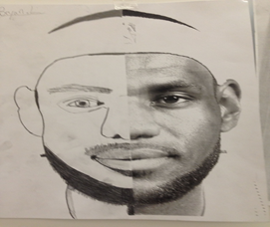
- Oh what a dot can be: Start by drawing a black dot in the middle of your page (about the size of a bottlecap). Then, draw anything you like and make sure the dot is part of the picture.
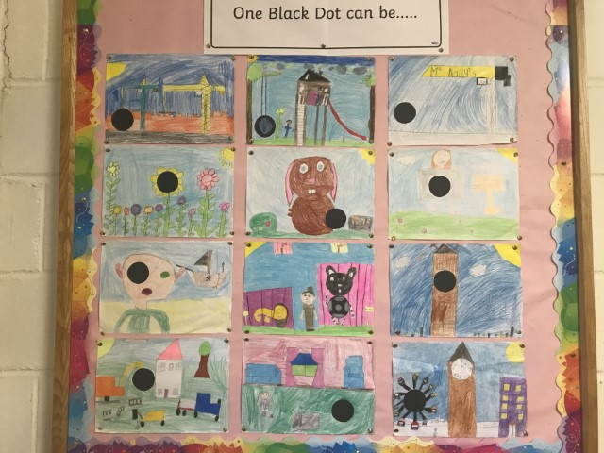

- This website has lots of cool art ideas that can be made from the recycling in your own home, choose your favourite and get crafting!
https://www.notimeforflashcards.com/2014/04/recycled-art-project-for-kids-2.html
- Diary: Write a daily account of what is happening in your life right now. By doing so you are making history for the future generation.
- Develop your computer skills. Learn how to type or become more familiar with Microsoft Word/PowerPoint. See https://online.maryville.edu/online-bachelors-degrees/management-information-systems/computer-skills-kids/
- Make a musical instrument from recycled materials in your house. If making a shaker, add salt or rice.
Compose an eight bar piece in ¾ time. Use the following notes: Ta-aa, ti-ti, ssh, tiri-tiri and ta. Use your instrument to tap out the beats in every bar.
- Additional science experiments can be found on www.sciencekids.co.nz.
- Bake or cooks your favourite meals and treats. These websites have lots easy and delicious recipes for kids!: https://www.bbcgoodfood.com/recipes/collection/kids-cooking
https://www.bbcgoodfood.com/recipes/collection/kids-baking
- Build a Fort out of couch cushions, furniture and blankets.
- Create a Mini-beast hotel in your garden for bugs to live in!
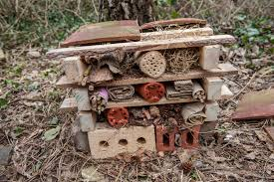
- Draw on the driveway with chalk! E.g. Hopscotch, Xs and Os, Twister, Snake and Ladders, Positive messages, an obstacle course, etc.
- Paint some stones to brighten up your garden!
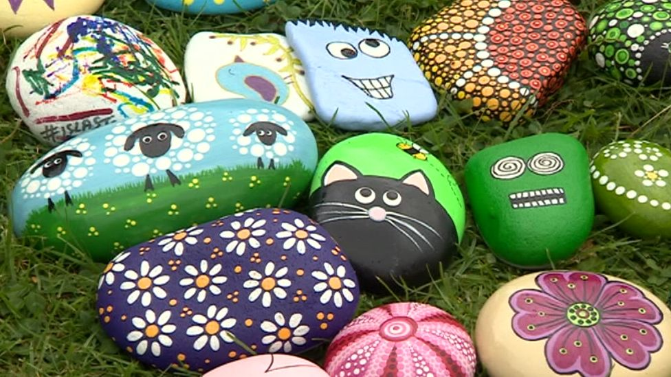
- Cycle your bike or go for a walk.
- Make a jigsaw.
- Mindful colouring: Mindful colouring can help you relax and use up a lot of time. Choice have giant colouring posters that will take you all summer to finish!
- Prepare a scavenger hunt around your house (give clues on post it notes, picture clues, colour scavenger hunt, alphabet scavenger hunt, etc.)
- Play some socially distant games: Simon Says, Ship Sea Shore, Beans, Fish and Chips, etc.
- Make a bird feeder: https://www.thesprucecrafts.com/bird-feeders-for-kids-to-make-2764688
- Have your own sports day!
- Bury a time capsule: Fill a box with items that you think represent this time and write a note about it, bury it in your garden and you’ll be able to dig it up in years to come!
- Interactive music lesson: https://youtu.be/zO3kdliOIQ8
- The Irish Institute of Music and Song are running an online music club between the 6th and 17th of July: https://www.irishinstituteofmusic.com/post/ireland-s-first-online-music-club-for-kids
- Still life drawing: Choose anything in your house or garden and draw it!
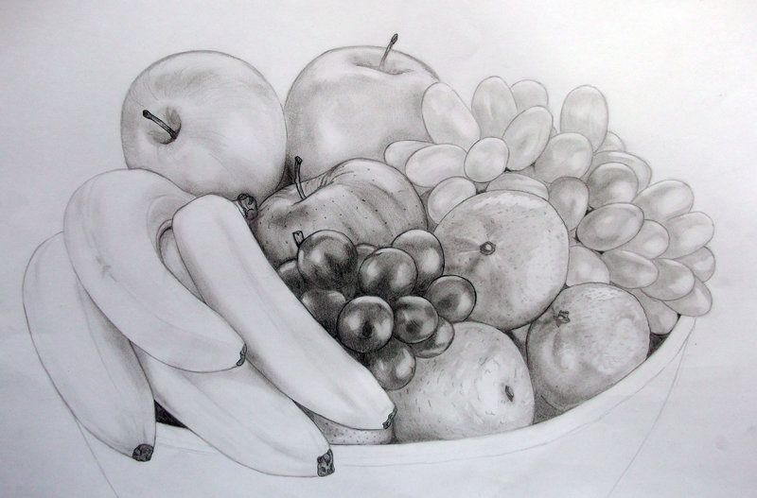
- Virtual tour of the Titanic: https://youtu.be/UOCSs8JYU5o
- National Geographic kids have lots of interesting videos such as Weird but True facts, Live Safari videos and videos about important events in history like Apollo 11: https://www.youtube.com/channel/UCXVCgDuD_QCkI7gTKU7-tpg/videos
- Here are some lovely summer-themed art ideas. If you don’t have paint, just use crayons or pencils instead!: https://www.artbarblog.com/40-summer-art-ideas-for-kids/
- Go to Dublin Zoo (virtually):
Safari watch- https://www.youtube.com/channel/UCCBFPR9ke2dbnHwNyhVi2kw
Live webcams (elephants, penguins, African savanna)- https://www.dublinzoo.ie/animals/animal-webcams/
- More creative ideas to learn while having fun: https://vipmagazine.ie/6-creative-ways-to-make-the-last-month-of-home-school-fun/?fbclid=IwAR0Mm9rDafXazu40QFs-WC0JDC2Uym22YTFCqFBLqVgLaBBjzh-uDFRxreU

